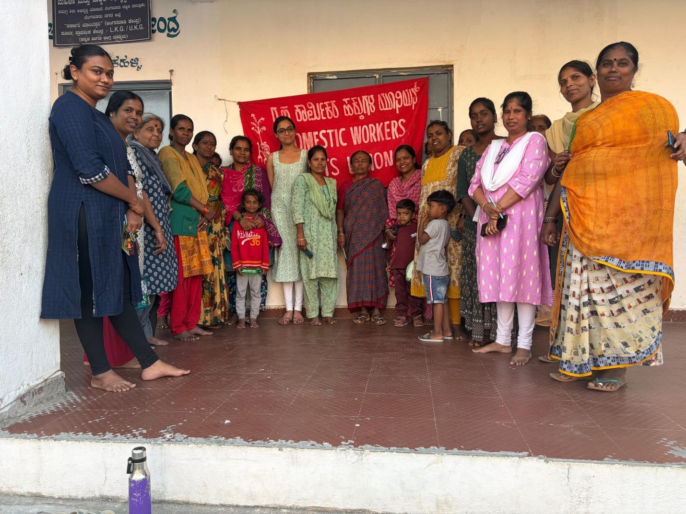
On 10th February 2026, Aishwarya from ALF conducted an awareness workshop in Bilekahalli

Aishwarya from the Alternative Law Forum (ALF) conducted an awareness workshop in Bilekahalli, Karnataka, regarding the Special Intensive Revision (SIR) of voter rolls, a process that has already led to the deletion of over 7 crore voters nationally. The SIR is a historic departure from past electoral practices because it shifts the burden of proof onto the citizen to demonstrate eligibility and citizenship, requiring them to link their names to the 2002 voter rolls and provide specific documentation for themselves and their parents. Critics, including ALF, fear this exercise acts as a covert implementation of the National Register of Citizens (NRC), disproportionately targeting marginalized groups like women, migrant workers, and minorities who may lack the 12 required documents or face technical discrepancies. In Karnataka, the implementation has been criticized for being opaque and hasty, characterized by a lack of public data from the Chief Electoral Officer and extreme pressure on Booth Level Officials. Ultimately, the workshop framed SIR as a violation of the constitutional right to universal adult franchise and called upon residents to demand transparency and pressure representatives to oppose what was described as a "voter cleansing" exercise.

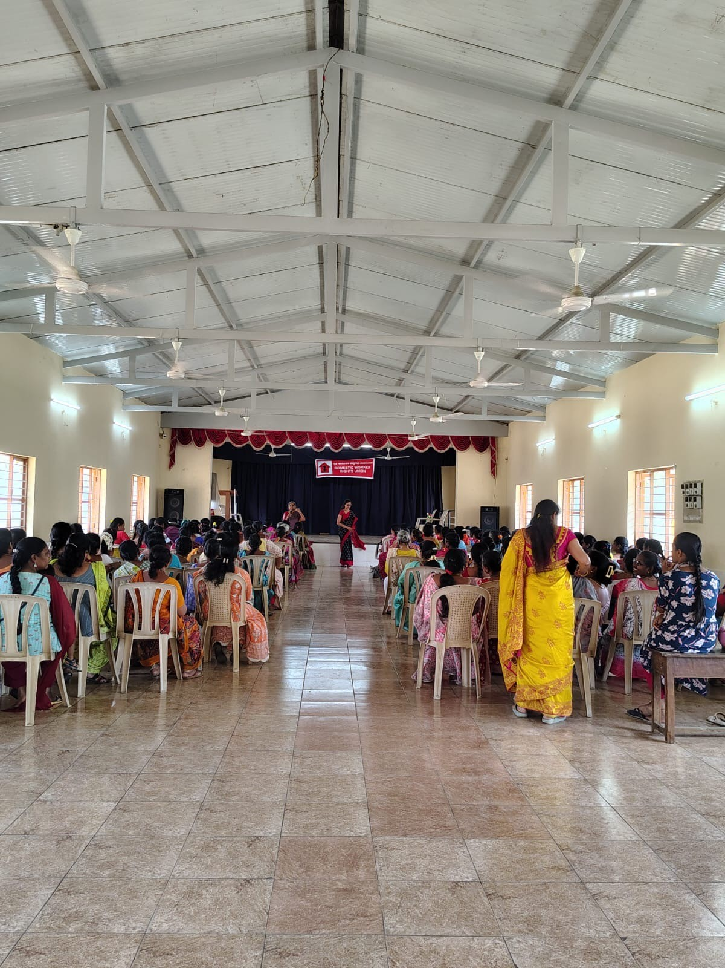
On March 11th 2026, Women’s Day program.

On March 11, 2026, the DWRU and Stree Jagriti Samithi organized an International Women’s Day program titled "From Struggle for Identity to Struggle for Citizenship," attended by approximately 150 women. The event served as a platform to discuss pressing issues such as "document poverty," where migration and lack of updated records lead to electoral erasure and exclusion from welfare schemes. The program included a unique Yakshagana performance by Sharvani, symbolizing the breaking of male-dominated artistic domains and the "Shakti" of women. Speakers from the Labour Department and PUCL emphasized the need for just legislation and the recognition of domestic workers as essential contributors to urban life.

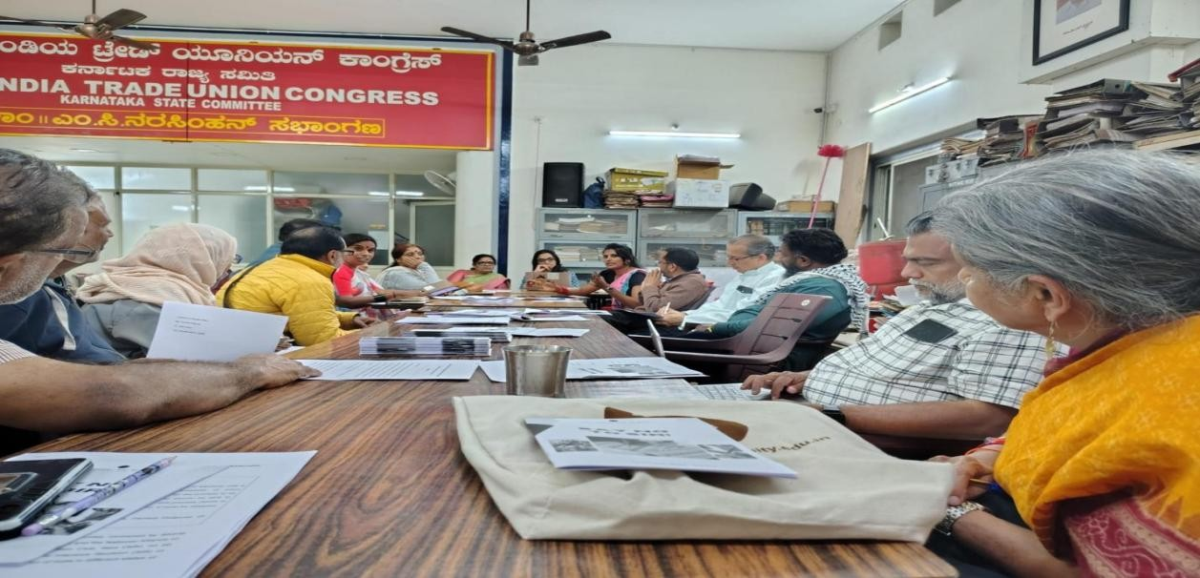
On 25th January 2026-Attended first meeting session to understand What SIRis and its effects
The union participated in an introductory session to analyze the Strategic Intervention Reform (SIR) and its far-reaching consequences across various Indian states. The meeting focused on understanding the socio-economic effects of these reforms and how their implementation has historically impacted marginalized labor sectors. By examining the diverse regional outcomes of the SIR, activists were able to identify patterns of displacement or exclusion that often accompany such large-scale policy shifts. This foundational session was essential for equipping the union with the knowledge needed to anticipate similar challenges in Karnataka and to develop informed advocacy strategies that protect the rights and identity of domestic workers amidst changing administrative frameworks.
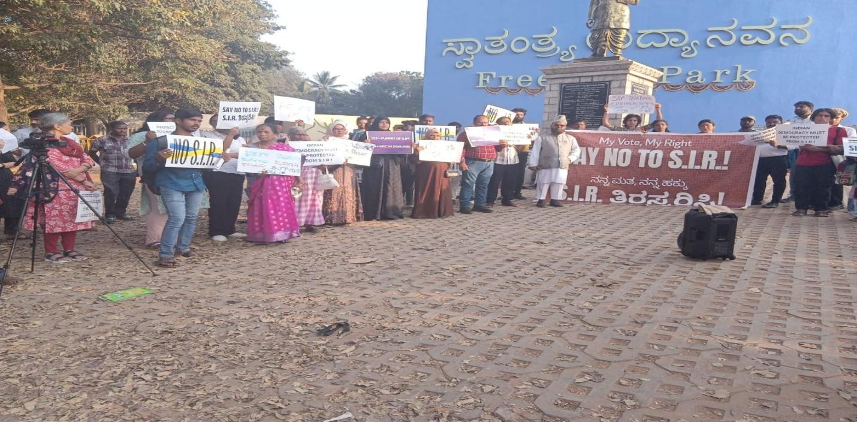On February 7th-Attended SIR Rally at Freedom Park
On February 7, 2026, a major protest organized by the "My Vote, My Right" coalition took place at Freedom Park in Bengaluru to oppose the Special Intensive Revision (SIR) of electoral rolls. Demonstrators, including civil rights activists, trade unions, and women’s groups, raised the slogan "Beda Beda SIR Beda" to voice concerns that the exercise could lead to the mass disenfranchisement of marginalized communities, particularly migrant workers and married women. The primary contention lies in the requirement for citizens to link their current status to 2002/2003 records, a "legacy linkage" that critics argue is opaque and places an impossible evidentiary burden on those without continuous documentation.
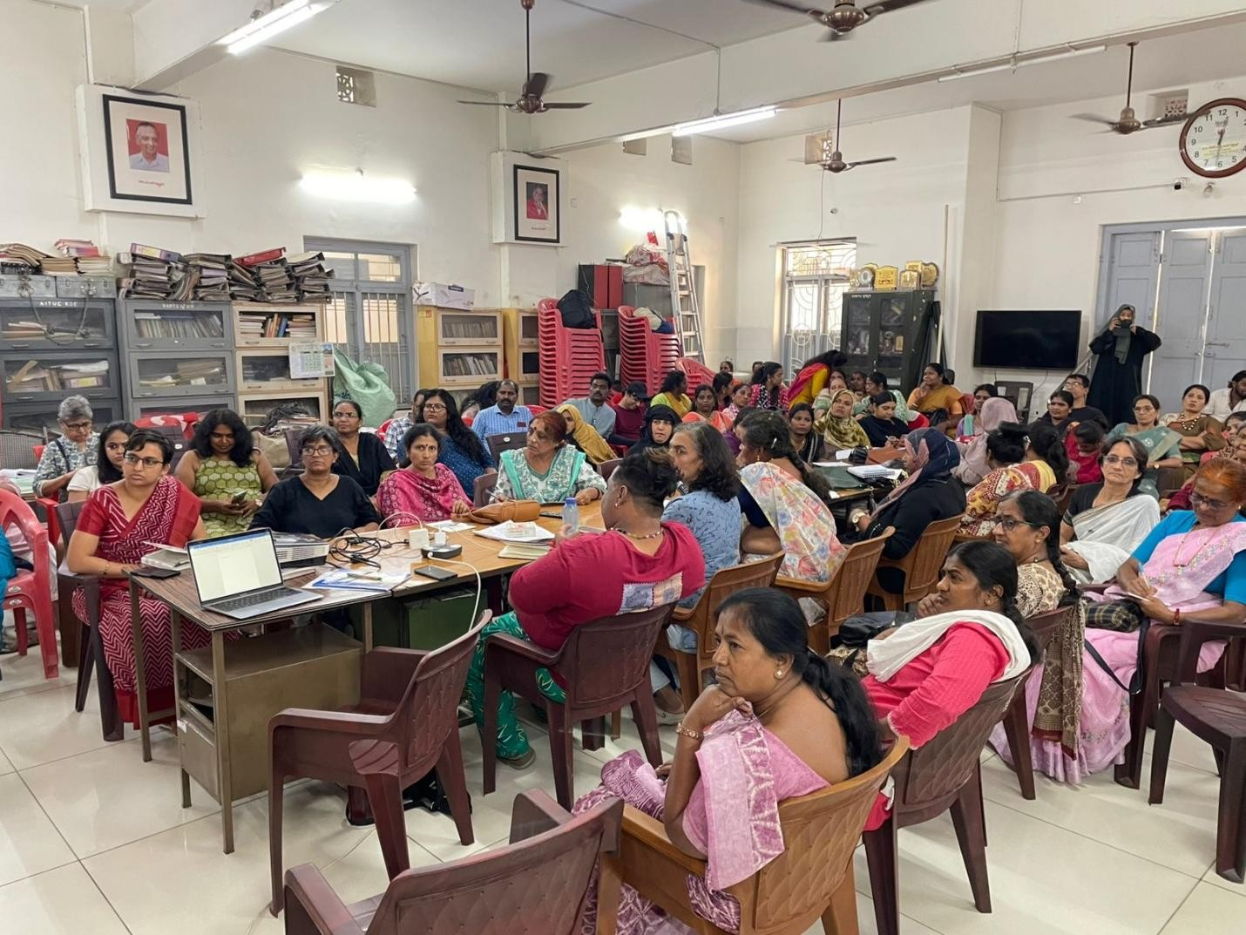On 28th February -Attended SIR Meeting (Belgaum team and Bengaluru team)
On 28th February 2026, attended a critical meeting for women’s organizations and collectives was held at the AITUC State Committee office in Seshadripuram, Bengaluru, to address the Special Intensive Revision (SIR) of electoral rolls. The gathering focused on the mapping process preceding the SIR, highlighting concerns from other states where marginalized communities and women have faced disenfranchisement and the loss of their fundamental right to vote. Participants aimed to strategize on taking this issue to the grassroots level and building a statewide democratic movement to safeguard voting rights against potential exclusion.

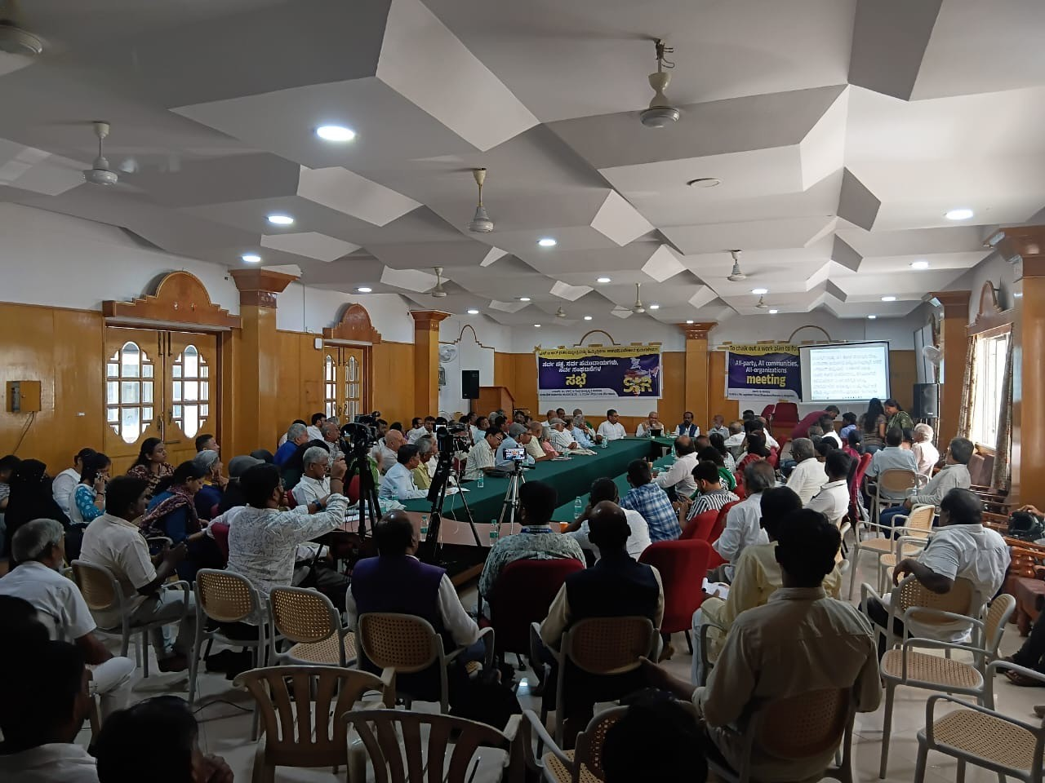
On 16th March 2026- Attended a conference by All party, All organisation meeting to chalk out a plan for SIR at Shaasakara bhavana.
The all-party and multi-organization meeting held on March 16, 2026, at the Legislators' Home in Bengaluru resulted in a resolute call for the immediate suspension of the Special Intensive Revision (SIR) mapping process in Karnataka. Leaders, including Nikhil Dey and S.G. Devasahayam, categorized the SIR as a "non-transparent" exercise that threatens the voting rights of millions, specifically by imposing an arbitrary 2002/2003 "legacy linkage" requirement. The assembly submitted a formal memorandum to the Chief Electoral Officer (CEO) raising 16 specific questions regarding the legal basis of the mapping and the potential for mass deletions of marginalized voters. Following this pressure and parallel public complaints about missing names in the draft rolls for the Greater Bengaluru Authority (GBA) elections, the State Election Commission was pushed to extend the deadline for filing claims and objections to March 20, 2026.

