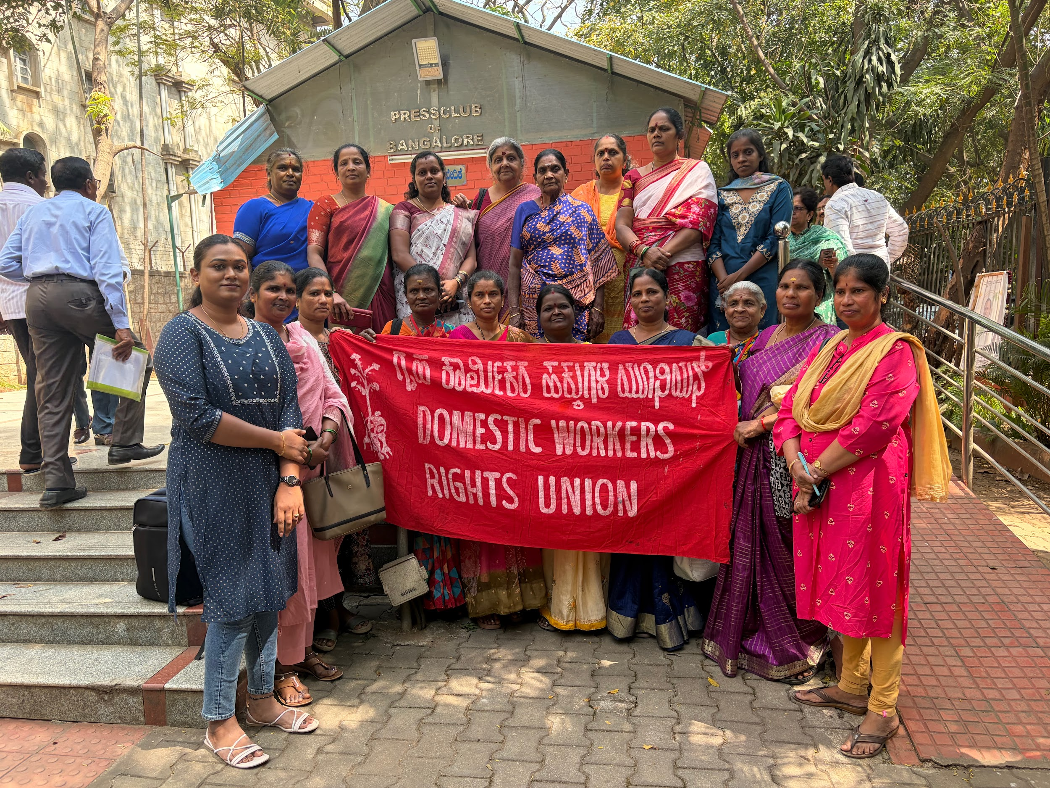
On 2nd February 2026, Had press meet

The period began with a significant legal challenge as ten registered domestic workers' unions, including the DWRU, addressed an open letter to the Chief Justice of India following the Supreme Court's refusal to entertain a petition for minimum wages on January 29, 2026 where we arranged a press meet on 2nd February 2026. This petition was the culmination of months of collective drafting by workers, leaders, and lawyers to secure a statutory declaration for minimum wage entitlements under Article 23 of the Constitution. Despite the Court directing the unions toward state governments due to the policy-heavy nature of wage fixing, the unions expressed deep concern that this dismissal prioritizes employer convenience over the constitutional rights of the poorest women workers. The DWRU has formally urged the Court to reconsider its decision and engage in a dialogue that recognizes domestic workers as full rights-bearing citizens.

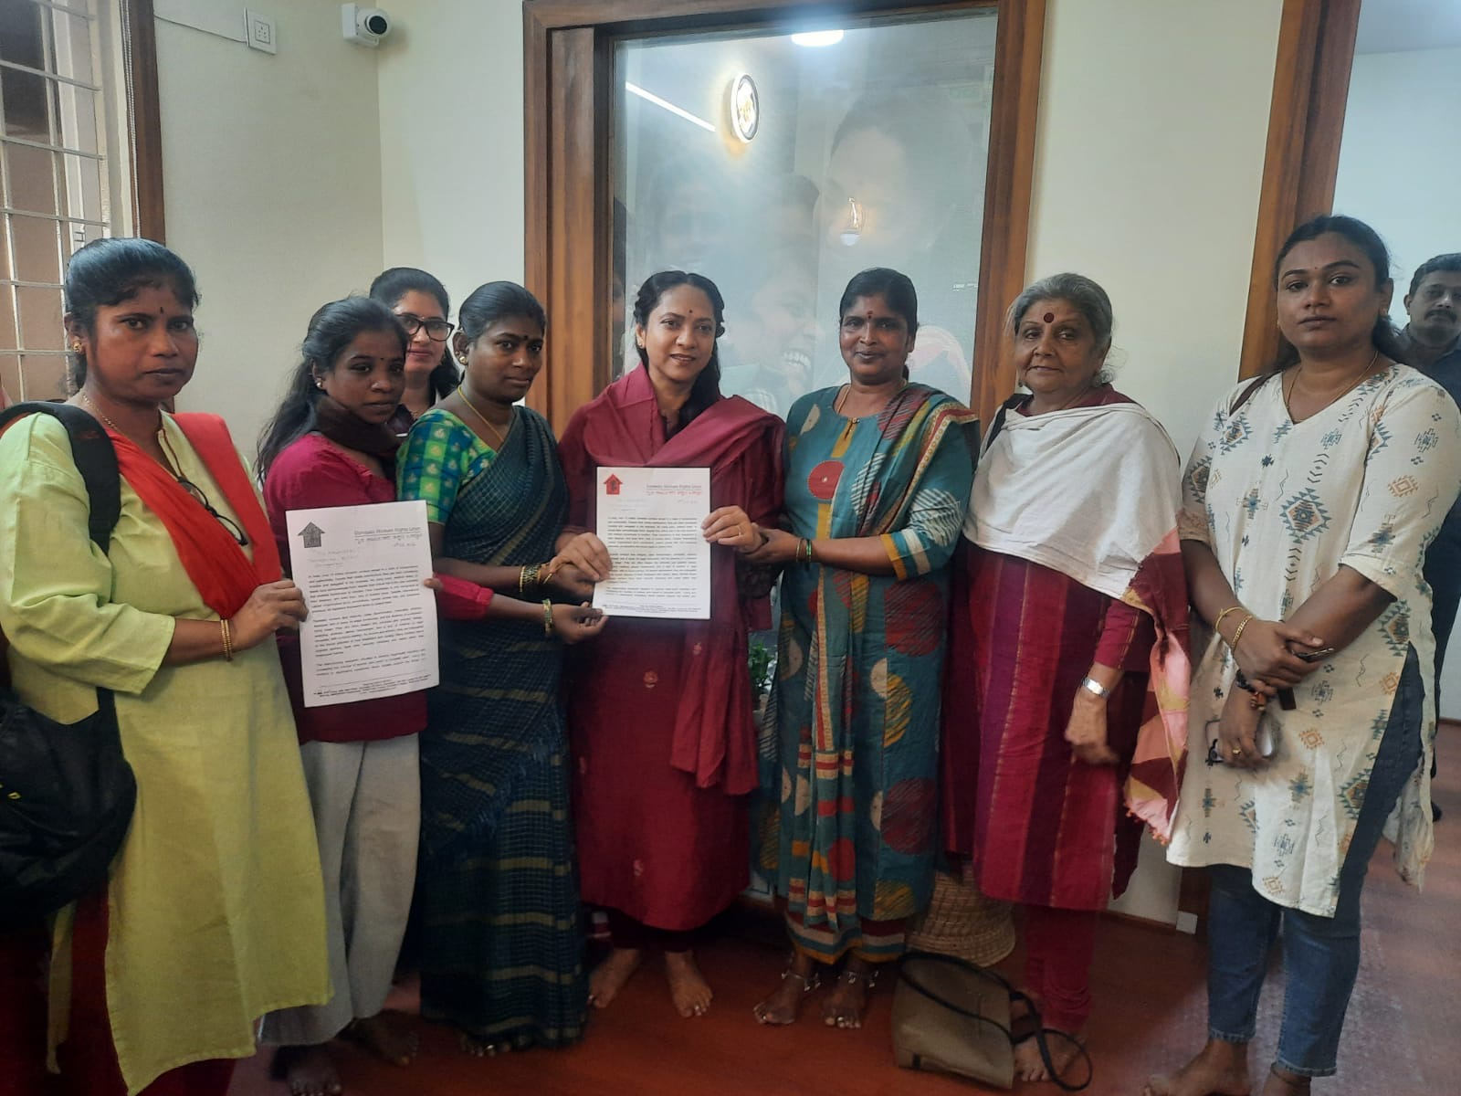
On 18th February 2026, met Dr. Nagalakshmi Chowdry

On February 18, 2026, a formal proposal was submitted to Dr. Nagalakshmi Chowdry, Chairperson of the Karnataka State Women and Child Welfare Commission, requesting a joint stakeholder meeting. The proposal highlighted the extreme vulnerability of the estimated 1.5 million domestic workers in Karnataka who face caste discrimination, lack of legal redress for violence, and exclusion from recent labor codes. By approaching the Women’s Commission, the DWRU aims to assert a feminist outlook that acknowledges the intersectionality of class, caste, and gender, demanding that housework be recognized as professional labor deserving of dignity, workplace safety, and social protection.
Next, March featured both high-profile commemorative events and direct administrative intervention.

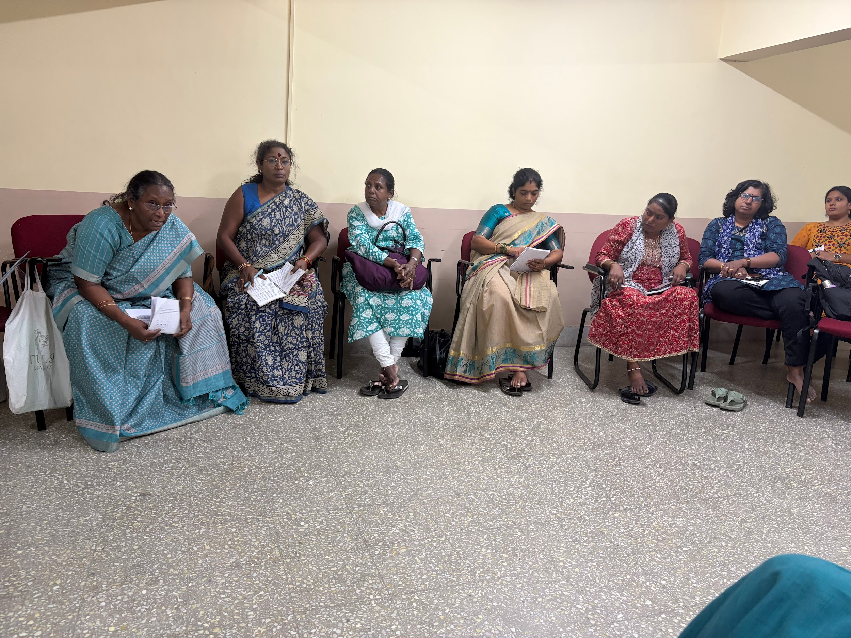
On 2nd March 2026, Conducted All Unions/NGO/CSO meeting on discussing the issues of new Domestic Workers Bill Draft.

On March 2nd, called out for a meeting with various unions focused on the Domestic Workers’ Rights Bill, where leaders expressed shock that the revised draft was "watered down," removing employer responsibility and failing to clarify wages or working conditions. A critical inter-union collective meeting was convened to evaluate the current status of the Domestic Workers’ Rights Bill. It was noted with great concern that although the draft bill had been in the public domain for a month, the version obtained from Cabinet officials revealed that the legislation had been severely watered down and weakened since the Belgaum session. The revised draft shifted all responsibility and potential penalties onto domestic workers while absolving employers of liability, and it lacked any clear framework for wage regulation or grievance redressal. The union, alongside the National Law School (NLS), submitted strong objections, asserting that a weak bill is worse than no bill at all and emphasizing the need for a unified stance to prevent the government from passing the legislation in its current, flawed state.

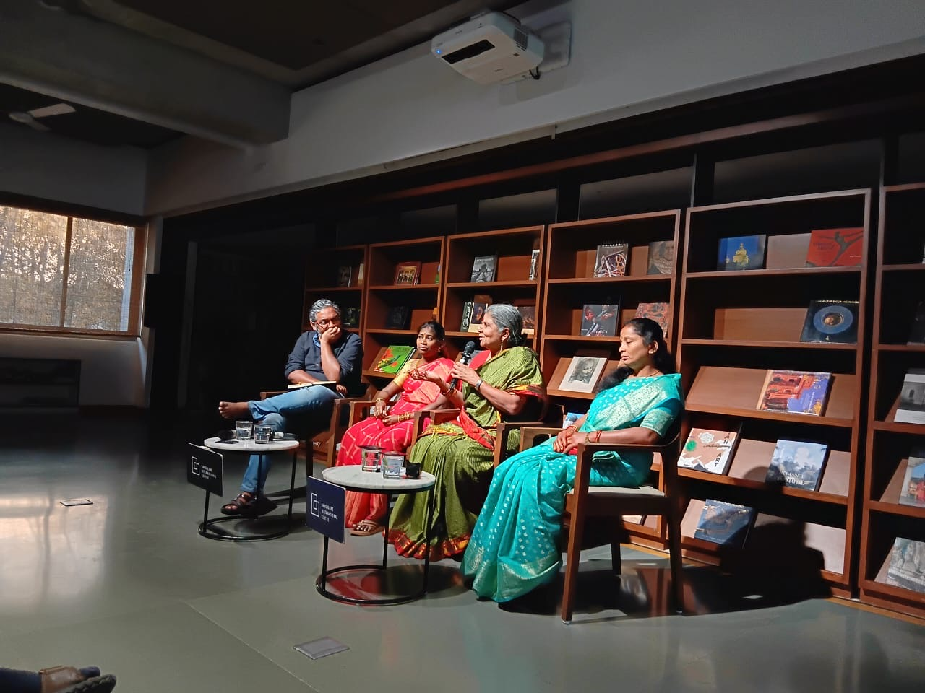On March 8th 2026- Attended International women’s day conference on HER LABOUR HER LAWS
In observance of International Women’s Day, the Bangalore International Centre hosted a seminar titled "Her Labour, Her Law," where advocates and our union leaders called for formal legal recognition of domestic workers to combat systemic invisibility and workplace discrimination. Speakers, including Geetha Menon of Stree Jagruti Samiti and representatives from the Domestic Workers Rights Union, highlighted how the sector remains entrenched in a "feudal" mindset characterized by arbitrary wage cuts, social exclusion, and a lack of basic facilities despite the urbanized economy. The session emphasized the urgent need for robust legal frameworks and collective action to address the intersectional challenges of caste, class, and gender that leave these essential workers vulnerable to exploitation and denial of basic dignity.

